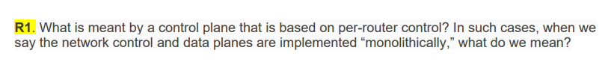 The control plane is used to forward or exchange of routing and forwarding tables.

Monolithically means that each router has a routing component which helps communication with the other routers that are routing components to compute the value of the forwarding table.

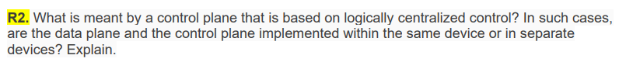

A control plane that is based on logically centralized control means that the functions of the control plane are performed on a single machine.

The data plane and the control plane are implemented within the same device.

 In centralized routing algorithms, the central node in the network gets the entire information about the network topology. Then, the information is sent to the respective routers. However, in a distributed network, the node receives information from it neighboring nodes and then makes the decision about the path to send the packet along.

An example of centralized routing is Link-State routing and an example of decentralized routing is Distance Vectoring.

 Every autonomous system does not need to use the same intra-AS algorithm because each of the system have their own administrative control for the sake of routing.

 False. Because OSPF does not send the link state info to nodes directly attached, it will send the information to all the routers in the system.



|  |  |  |  |  |  |  |  |
| --- | --- | --- | --- | --- | --- | --- | --- |
|  | X | Y | Z | T | U | V | W |
| X |  | 6 | 8 |  |  | **3** | 6 |
| V |  | 6 | 8 | 4+3=7 | 3+3=6 | **3** | 6 |

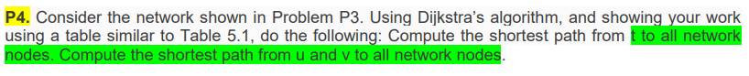

|  |  |  |  |  |  |  |
| --- | --- | --- | --- | --- | --- | --- |
|  | U | V | W | X | Y | Z |
| T | **2** | 4 |  |  | 7 |  |
| U | **2** | **4** | 2+3=5 |  | 7 |  |
| V |  |  | **2+3=5** | 4+3=7 | 7 |  |
| W |  |  |  | 4+3=7 | 7 |  |
| Y |  |  |  |  |  | 7+12=19 |



**Z as source**

|  |
| --- |
| Z to v |
| Z to v = 6 |
| Z to x to v = 5 |
| Z to x to y to u to v = 8 |
| Z to x |
| Z to x = 2 |
| Z to v to x = 9 |
| Z to v to u to y to x = 12 |

|  |
| --- |
| Z to y |
| Z to x to y = 5 |
| Z to v to u to y = 9 |
| Z to x to v to u to y = 8 |
| Z to u |
| Z to x to y to u = 7 |
| Z to x to v to u = 6 |
| Z to v to u = 7 |